**SUPPLEMENT: SARS-CoV-2 testing strategies to contain school-associated transmission: model-based analysis of impact and cost of diagnostic testing, screening, and surveillance**

Alyssa Bilinski PhD1; Andrea Ciaranello MD2; Meagan C. Fitzpatrick PhD3; John Giardina MA4; Maunank Shah MD, PhD5; Joshua Salomon PhD6; Emily A. Kendall MD, PhD5

1 Department of Health Services, Policy, and Practice and Department of Biostatistics, Brown School of Public Health, Providence, RI, USA

2 Medical Practice Evaluation Center and Division of Infectious Disease, Massachusetts General Hospital, Harvard Medical School, Boston, Massachusetts

3 Center for Vaccine Development and Global Health, University of Maryland School of Medicine, Baltimore, Maryland

4 Center for Health Decision Science, Harvard T.H. Chan School of Public Health, Boston, MA

5 Division of Infectious Diseases, Johns Hopkins University School of Medicine, Baltimore, MD

6 Center for Health Policy and Center for Primary Care and Outcomes Research, Stanford University School of Medicine, Stanford, California

**Model Structure**

We assumed an SEIR model of COVID-19 transmission, using a previously published model [(1)](https://www.zotero.org/google-docs/?zVl8Ao). Briefly, when individuals interacted with an agent (i.e. person) infected with SARS-CoV-2, transmission risk was proportional to duration and intensity of exposure. The model drew stochastic outcomes assuming an average incubation period of three days prior to the onset of infectiousness, two days of pre-symptomatic transmission if symptoms develop [(2,3)](https://www.zotero.org/google-docs/?r69PNZ), total infectious time of five days [(4–7)](https://www.zotero.org/google-docs/?ZsfHYD), and overdispersion of infectivity in adolescents and adults [(4,8)](https://www.zotero.org/google-docs/?7tIyZT) (Table 1). We assumed that adults with fully asymptomatic disease transmit COVID-19 at half the rate of those with any symptoms [(9)](https://www.zotero.org/google-docs/?tjGehx). Based on data from household contact tracing studies, we further specified that, in absence of vaccination, children under 10 were half as susceptible and half as infectious as symptomatic adolescents and adults [(10–14)](https://www.zotero.org/google-docs/?esby8K). Beyond interactions with infectious agents within the simulation, students, staff, and their families had a probability of becoming infected through other community interactions equivalent to community per capita daily incidence assuming a 33% case detection rate. In vaccinated individuals, this risk was reduced by 80%; among unvaccinated adults, we upweighted community risk such that adults overall matched the community rate on average.

In scenarios without “test to stay”, symptom-driven COVID diagnostic testing still occurred outside of the school environment: individuals with COVID-19 who developed clinically-recognizable symptoms were assumed to self-isolate from out-of-household contacts (including staying home from school) and to obtain testing in the community. Results became available 24 hours after the first appearance of symptoms, at which point classrooms were notified and quarantined for 10 days. Symptom-driven community-based testing, and self-isolation of symptomatic individuals who had not been tested since symptom onset, were assumed to occur regardless of in-school screening practices.

For in-school testing, we assumed (a) specimens (e.g., anterior nasal swabs) were collected from each student and teacher, and (b) aliquots from up to eight specimens obtained in a single classroom were combined for pooled PCR testing, with negligible loss of sensitivity to detect active infection [(15,16)](https://www.zotero.org/google-docs/?Yv1kg7) When a pooled specimen yielded a positive result, all individual specimens that had been included in the pool were immediately tested separately using PCR to identify the positive individual(s).

**Model Parameterization and Calibration**

Model parameterization is discussed at length in the Supplement of [(1)](https://www.zotero.org/google-docs/?exg6PE). Briefly, we first identified household attack rates (including differential susceptibility and infectiousness of young children) [(17–19)](https://www.zotero.org/google-docs/?YD7t9F). We first adjusted these for the length of time spent in school and reduced infectiousness of asymptomatic individuals [(9)](https://www.zotero.org/google-docs/?X0TEut) to estimate attack rates with no or minimal mitigation. We then further adjusted them for a range of mitigation strategies. To partially validate our model, we compared our estimates of in-school attack rate and in-school Rt to those from empirical studies. We estimated in-school Rt with high mitigation and classroom quarantine and “bubbles” to be 0.2 for elementary schools and 0.64 in high schools, consistent with estimates from schools during 2020-2021 (e.g., [(20)](https://www.zotero.org/google-docs/?KP42fI)). Our estimates also reflect the wide range of attack rates across mitigation levels identified both in data directly from schools [(21–23)](https://www.zotero.org/google-docs/?gWFcZA) and from household/population-level estimates [(24,25)](https://www.zotero.org/google-docs/?se3ZGB), as well as the association between community incidence level and transmission risk [(26)](https://www.zotero.org/google-docs/?AjSz4y).

We assumed that the delta variant is twice as transmissible than the wild type variant [(27,28)](https://www.zotero.org/google-docs/?1lytkK) and that this multiplicative increase is constant across levels of mitigation. The latter assumption is uncertain and requires further empirical evaluation in different contexts; for example, while it may be realistic with cloth masks, early anecdotal evidence from health care settings suggests that high filtration masks (e.g. N95, KN95) may protect nearly as well against the delta variant as they do against wild type. We also assumed that the delta variant has 80% vaccine efficacy, a decrease compared to the wild type [(29,30)](https://www.zotero.org/google-docs/?HbMNs9). Some emerging estimates of vaccine efficacy are lower, potentially suggesting a conservative estimate of the value of screening.

For our base case, we assume high mitigation with the delta variant (Rt of approximately 0.4 in elementary schools and 1.2 in middle schools) to reflect the population of schools most likely to implement testing and likely ordering of interventions (e.g., testing will likely only be implemented in schools that have already implemented masking). We also present results with moderate mitigation, doubling the attack rate of the base case, to display the impact of testing in the context of reduced mitigation interventions in schools.

**Surveillance Thresholds**

Within a small school community, it is challenging to set an optimal threshold for triggering further investigation when conducting surveillance. We expect some COVID-19 cases to enter a school from the community *even if no transmission occurs within the school community*, and ideally the threshold for triggering additional testing should take this into account. However, when testing only a small fraction of the school (10-20%), the expected number of asymptomatic cases detected per testing episode, assuming no in-school transmission, is generally close to 0. In the paper, we chose a 1-case trigger threshold for 3 reasons:

1. At low-to-moderate community notification rates (1-25 cases per 100,000/day), no surveillance scenario with a threshold above 1 could detect even large outbreaks of at least 10 in-school transmissions with any regularity: the maximum probability of detection (i.e., maximum sensitivity) was 35% for a 2-case threshold at 25 cases per 100,000/day. By contrast, a 1-case threshold had a detection probability of 30-75% across 1-25 cases per 100,000/day, while maintaining low rates of false positive triggers.
2. In our model, there was generally at least some in-school transmission at high levels of community incidence, making threshold selection less of a concern, since false positives would be rare under any threshold. (For the same reason, surveillance testing as a method of detecting outbreaks is less useful at these levels, although a benefit remains if community case detection is low, which makes schools less likely to be aware of local incidence risks.)
3. If, in practice, a school calibrated the expected number of cases and associated threshold to the *observed* community incidence rate, this would be a significant underestimate (and for most community incidence levels we evaluated would be near 0). (However, it is not straightforward to correct for case detection, as there is no public, consistently-collected data source in the United States for estimating case detection rate, and most school leaders with whom we spoke would not be comfortable making such an estimate.[1])

Nevertheless, schools (or school districts more broadly) should adapt surveillance thresholds to meet their needs and level of caution. Our model is a st example over a single month for a single school. A longer-term strategy might include dynamic switching back to surveillance as well as stricter trigger thresholds when community incidence is high or when surveying large districts.

**Fig S1. Model diagram**

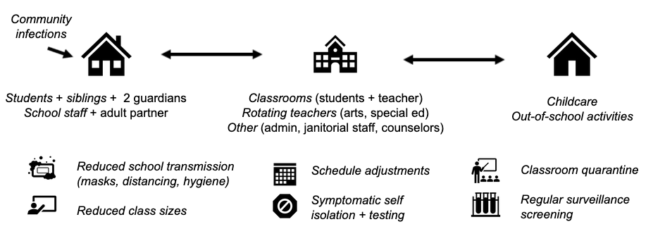

**Fig S2. Surveillance characteristics.** Color indicates the percentage of the school screened weekly (from unvaccinated individuals) under surveillance, while the line type indicates the transmission level. The left panels depict the probability of triggering screening. The middle panels depict the probability of in-school transmission, conditional on triggering screening (“true positives”). The right panels depict the probability of fewer than 3 in-school transmissions given no screening trigger (“true negatives”).

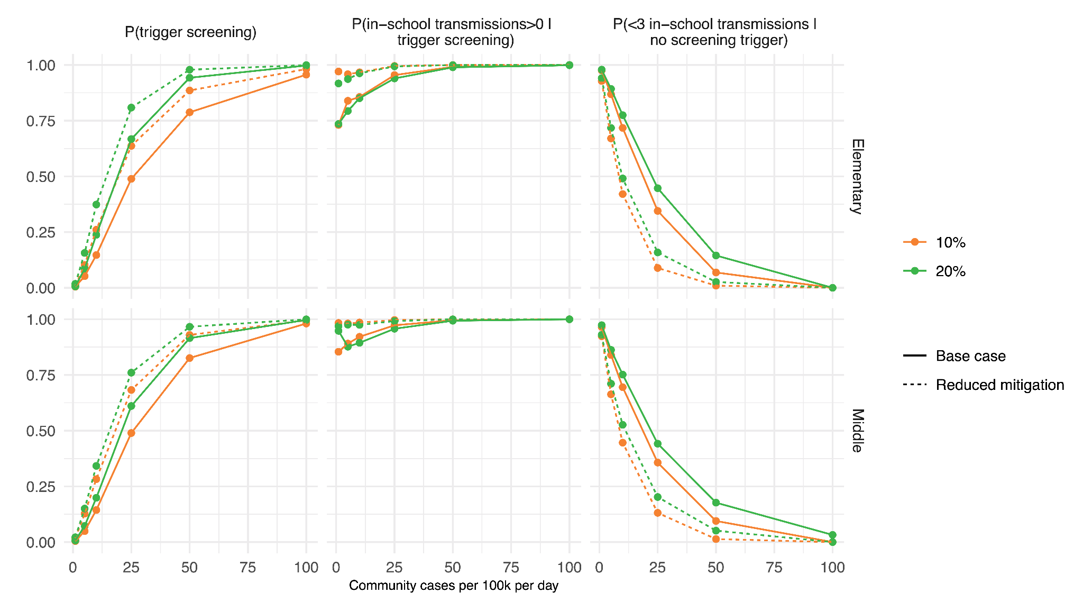

**Fig S3. Testing costs, as dollars per student per month, in an elementary school.** When exposed students quarantine at home, costs plateau at higher levels of incidence as classroom quarantines cause screening days to be missed; potential costs of community-based testing by exposed students or their contacts are not modeled. For a “test to stay” strategy that provides in-school rapid testing to symptomatic students and exposed contacts, testing costs increase as incidence rises.

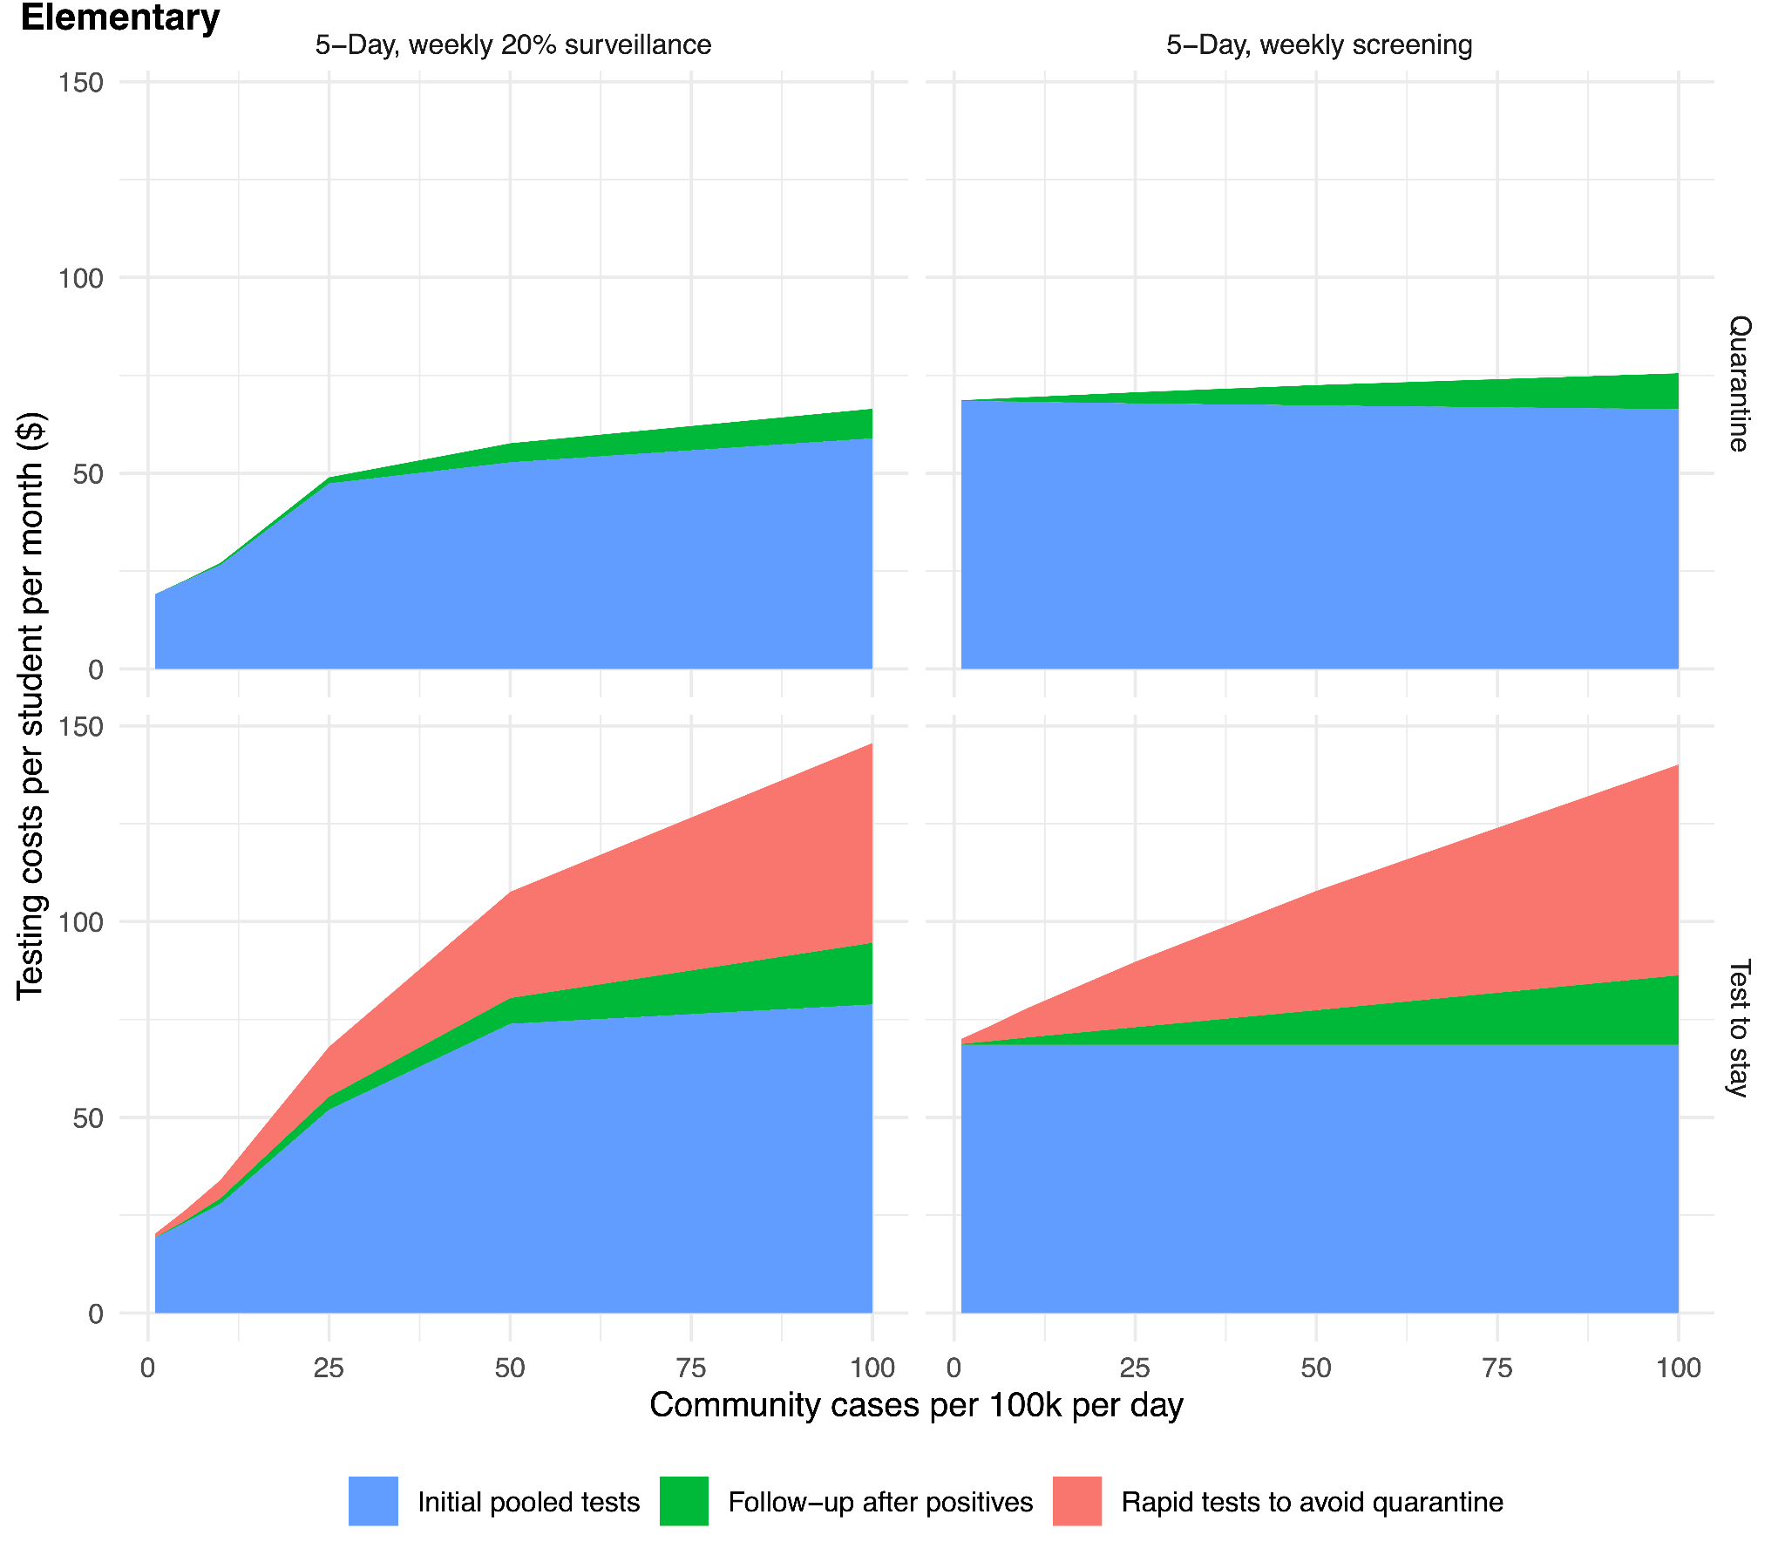

**Fig S4. Testing costs, as dollars per student per month, in a middle school.** When exposed students quarantine at home, costs plateau at higher levels of incidence as classroom quarantines cause screening days to be missed; potential costs of community-based testing by exposed students or their contacts are not modeled. For a “test to stay” strategy that provides in-school rapid testing to symptomatic students and exposed contacts, testing costs increase as incidence rises.

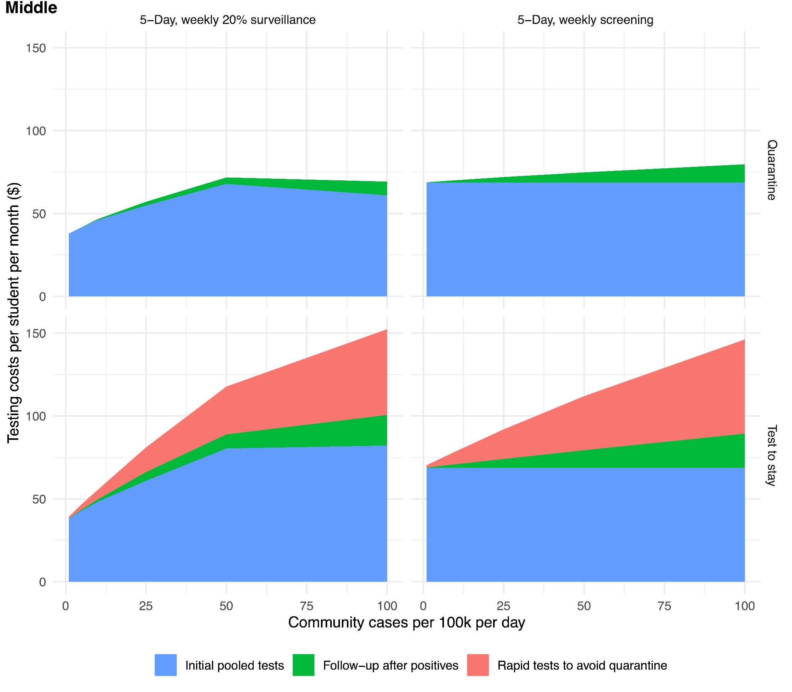

**Fig S5. Childcare or parent productivity costs (elementary school).** Planned costs reflect scheduled days of remote learning, and unplanned costs reflect days spent in isolation or quarantine. Rows reflect two different approaches to managing exposed contacts (quarantine for 10 days at home, top row; or staying at school with a week of daily rapid tests, bottom row). “Test to stay” is not modeled for Hybrid and Remote schedules.

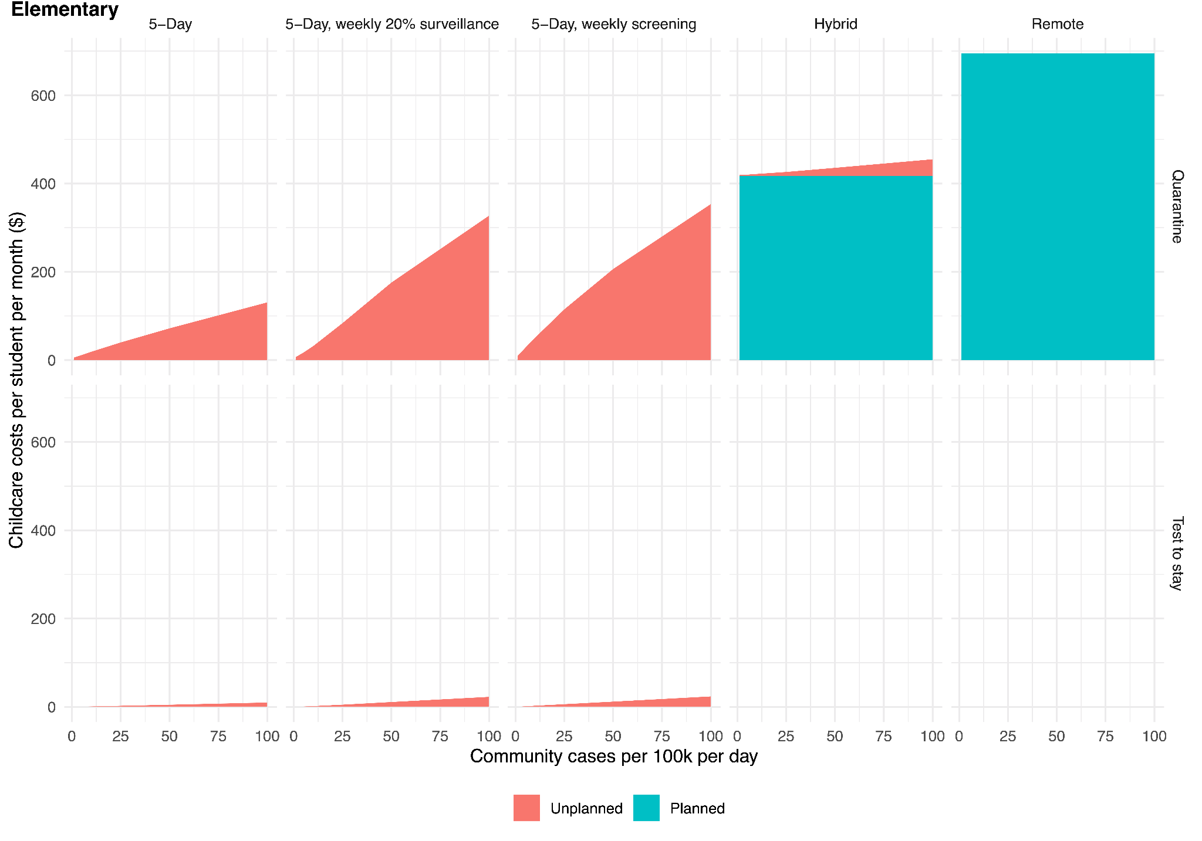

**Fig S6. Childcare or parent productivity costs (middle school).** We assume that for a combination of health and logistical reasons, full classrooms quarantine after exposure. If only unvaccinated students were asked to quarantine, then costs of 5-Day + Quarantine scenarios would be reduced.

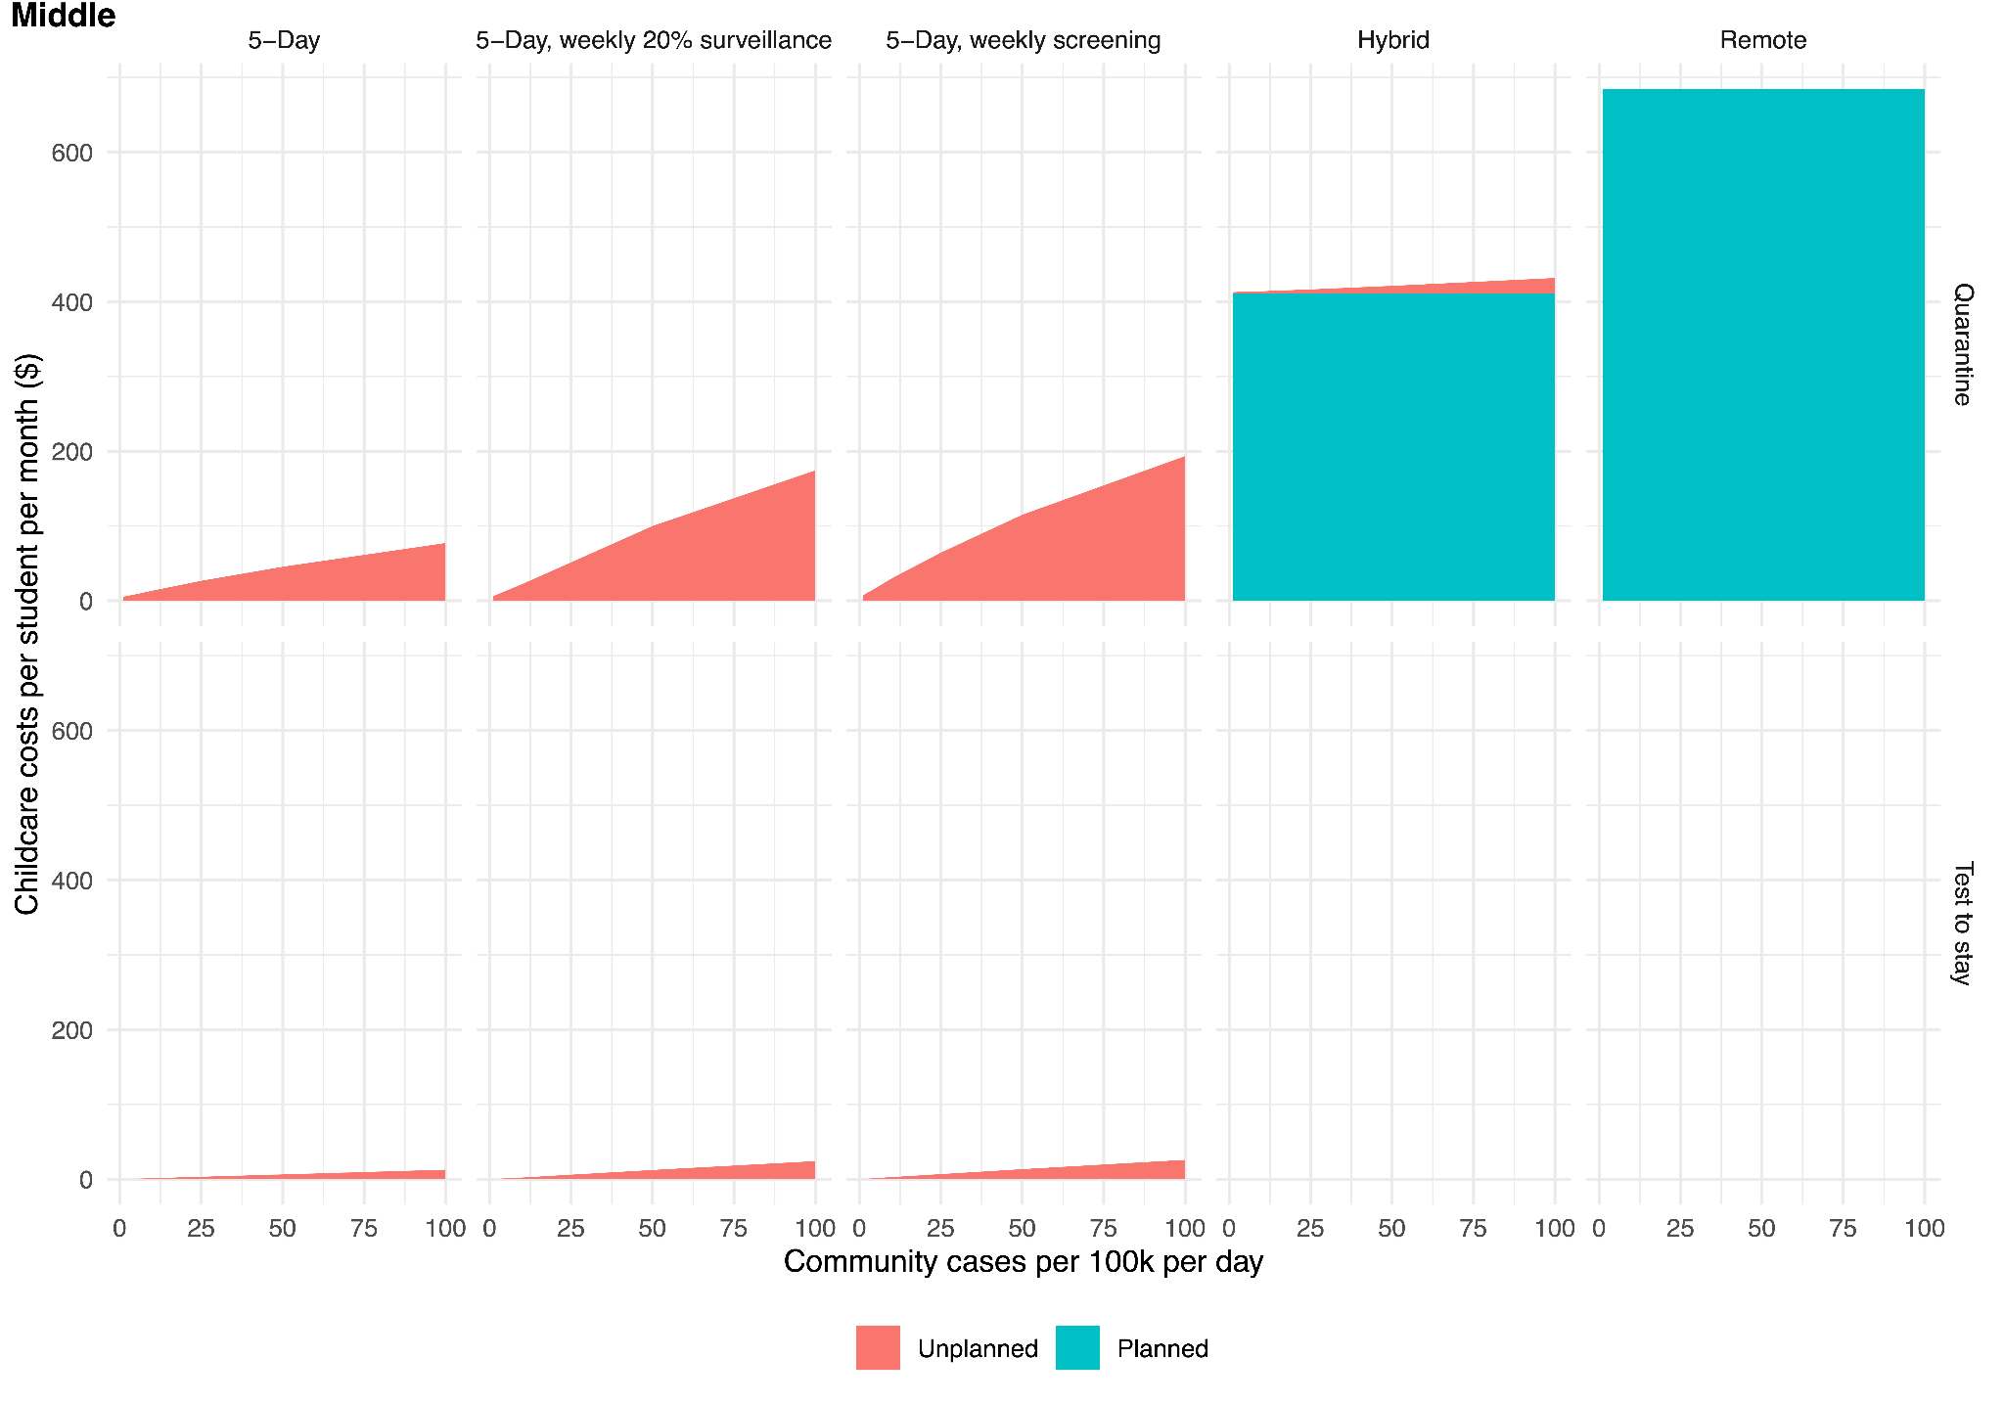

**Fig S7. Costs associated with rapid antigen screening tests** (weekly tests at $12 per test + $8 per sample collection, PCR confirmation of positive results with same one-day turnaround, 0.5% false positive rapid tests, no change in sensitivity for acute infection) compared to the costs of schedule-based mitigation and of full-time in-person attendance without asymptomatic screening.

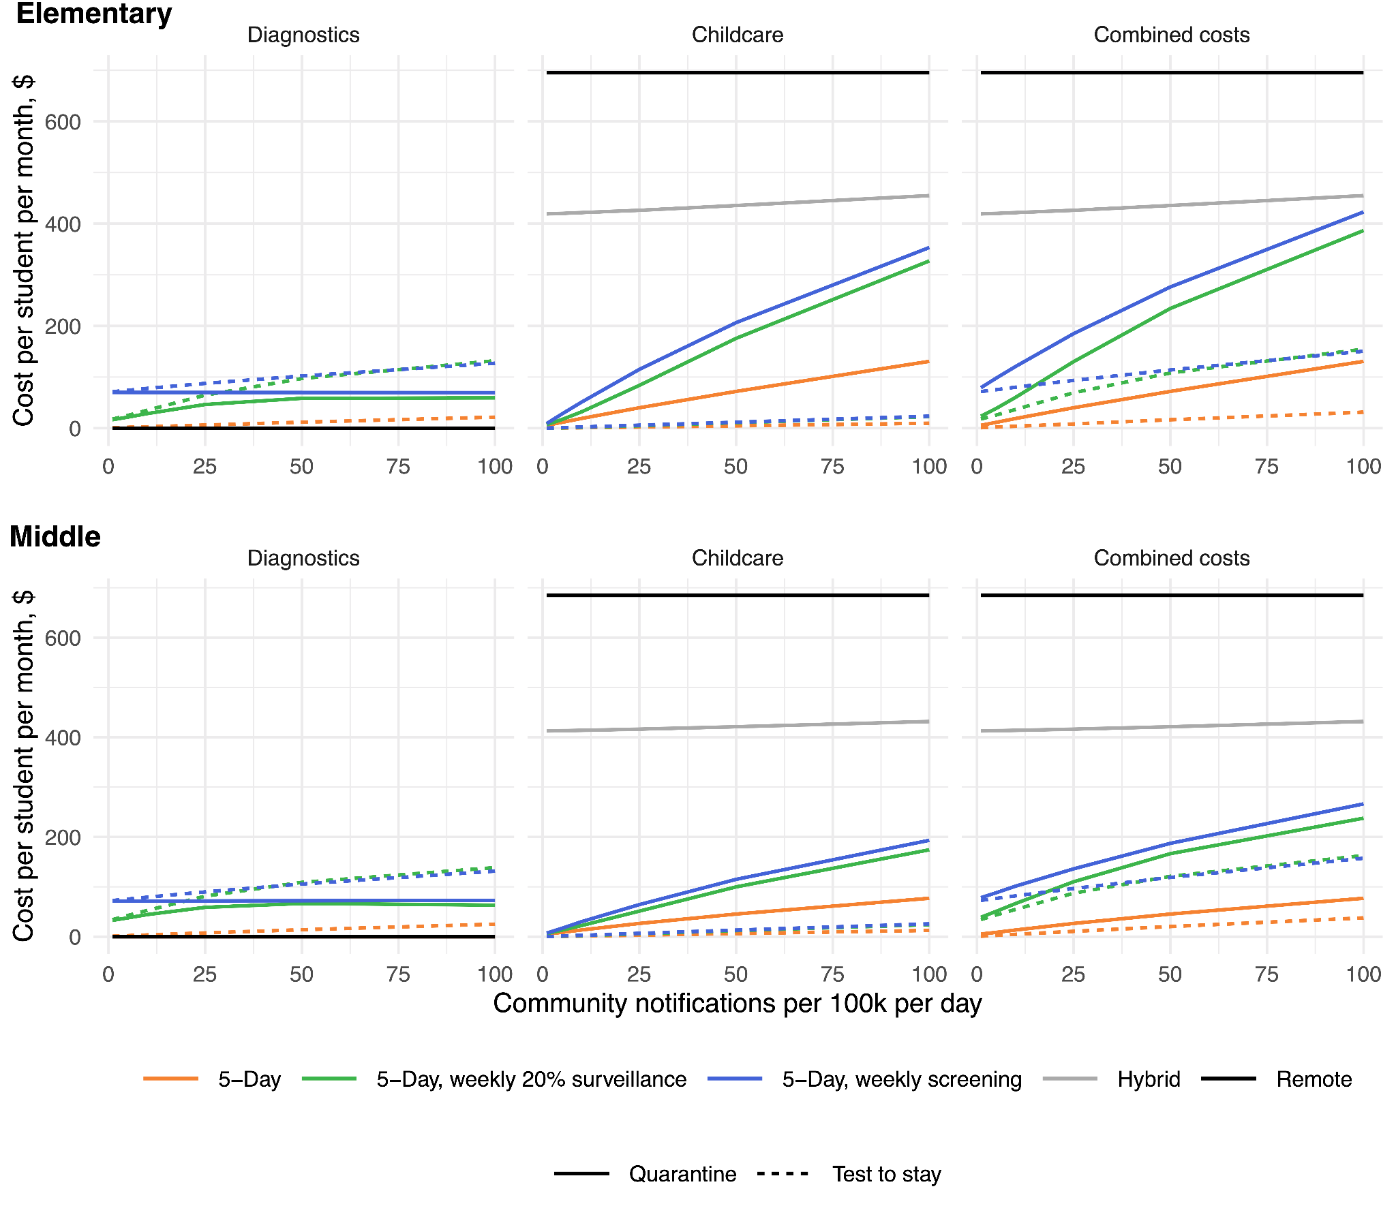

**Fig S8. Cost-effectiveness of rapid screening (cost per infection directly averted among students and staff), comparing weekly screening to full-time attendance without screening, under the same rapid screening assumptions as in Figure S7.** For testing costs (orange), we show the strategy of weekly screening in which exposed contacts quarantine at home (solid line), which dominates the “test to stay” strategy. By “dominates”, we mean that if optimizing over test costs only, it is strictly higher value to quarantine contacts, rather than implement test-to-stay. Likewise, for combined costs of testing plus childcare (blue), we show the strategy of weekly screening with exposed contacts undergoing daily rapid tests to stay at school (dashed line), which dominates at-home quarantine.

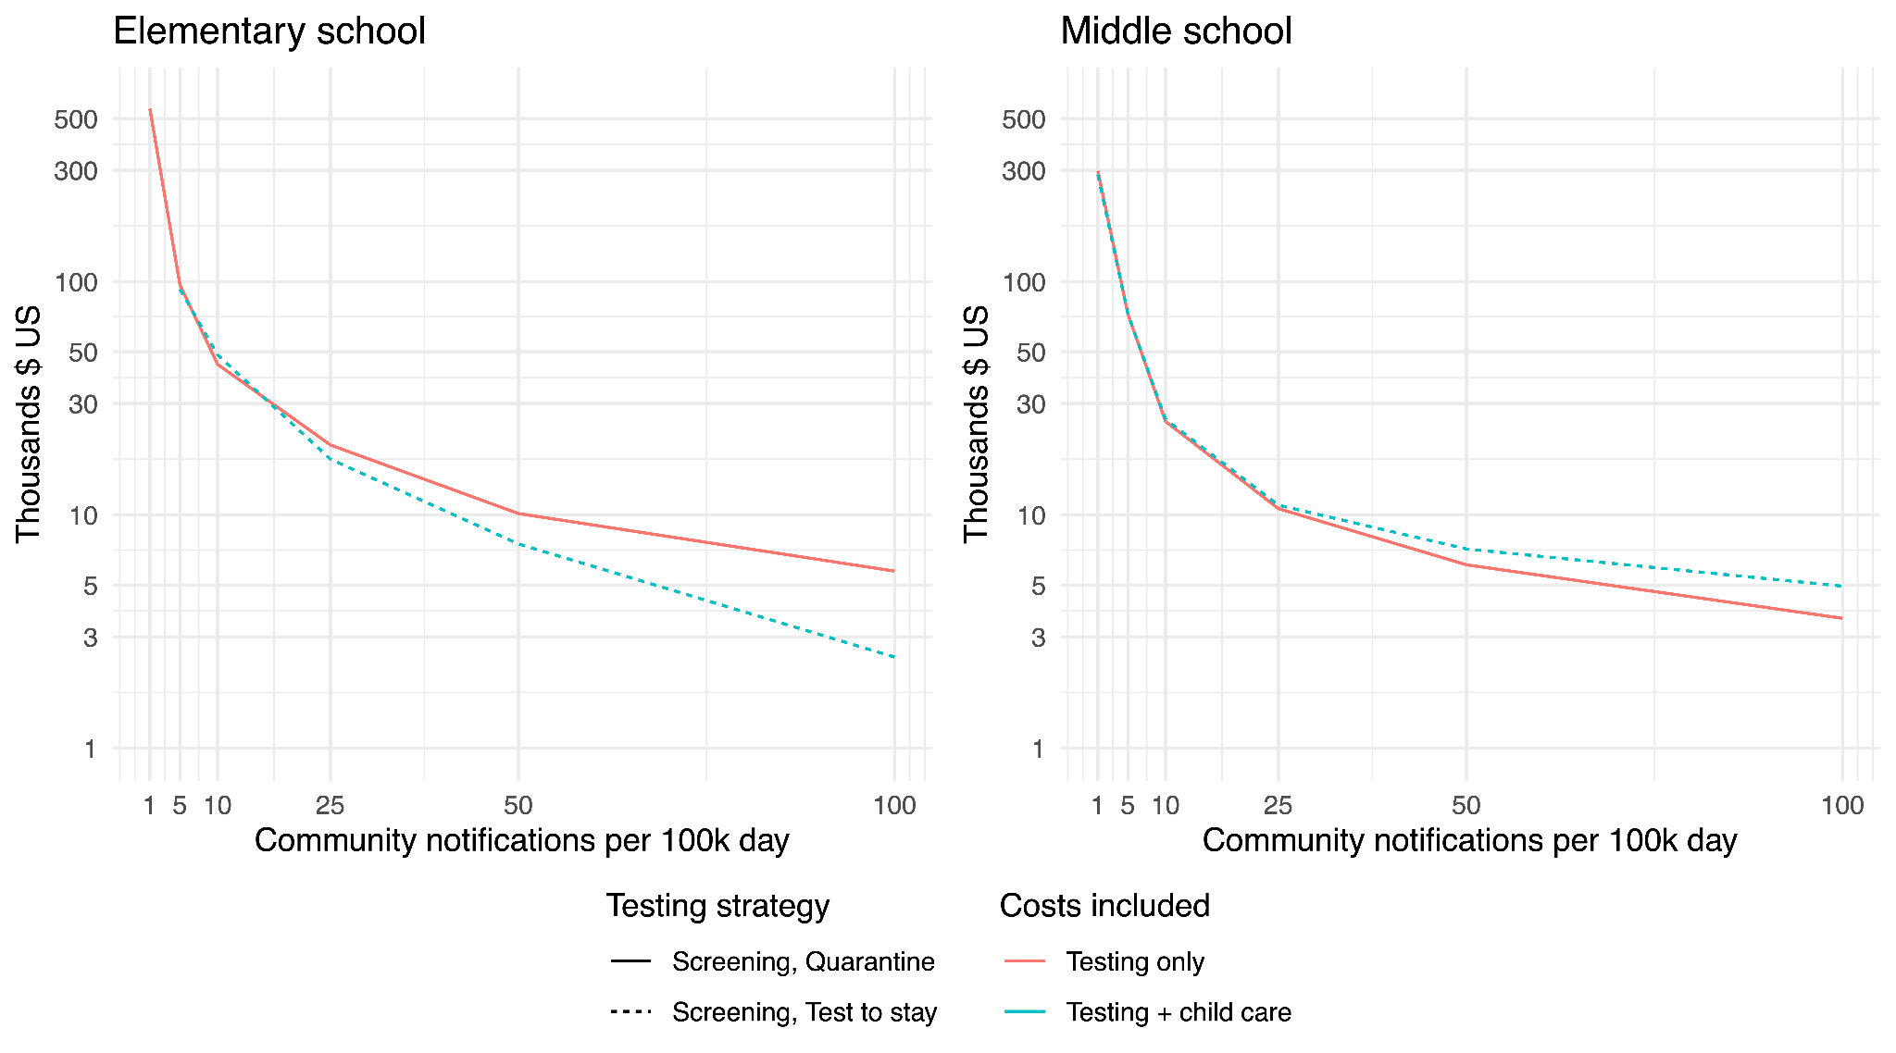

**Fig S9. Cost-effectiveness of weekly screening (cost per infection directly averted among students and staff), comparing screening to full-time attendance without screening, assuming a two-fold increase in transmission rate over the base case (due to increased variant transmissibility or reduced in-school mitigation).** For testing costs (orange), we show the strategy of weekly screening in which exposed contacts quarantine at home (solid line), which dominates the “test to stay” strategy. By “dominates”, we mean that if optimizing over test costs only, it is strictly higher value to quarantine contacts, rather than implement test-to-stay. Likewise, for combined costs of testing plus childcare (blue), we show the strategy of weekly screening with exposed contacts undergoing daily rapid tests to stay at school (dashed line), which dominates at-home quarantine.

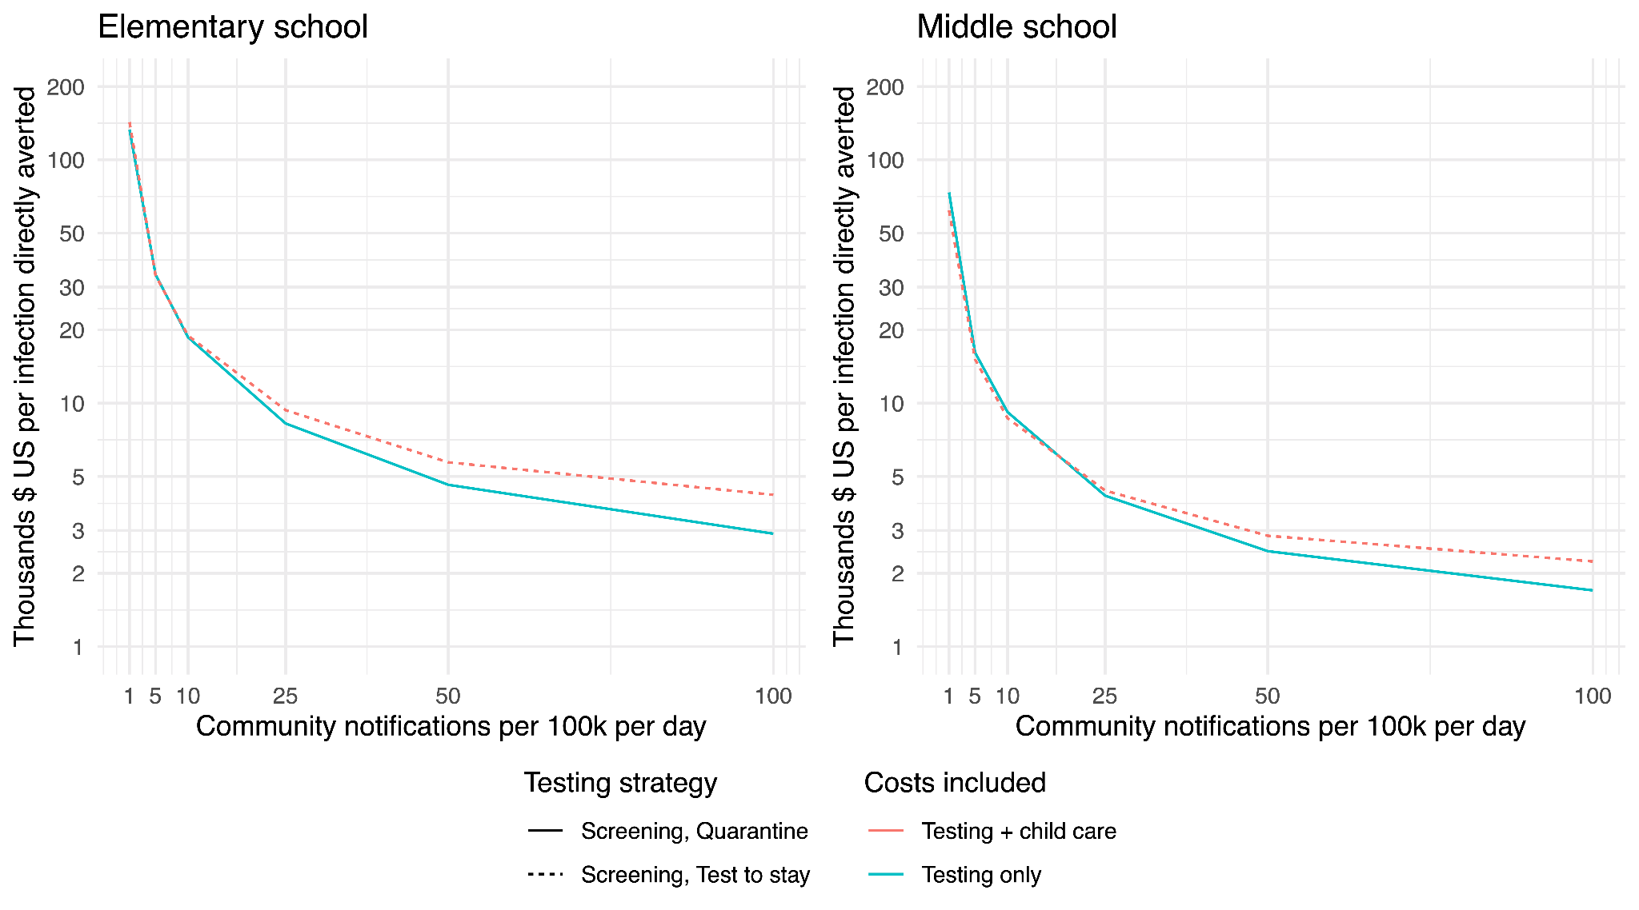

**Fig S10. One-way sensitivity analyses, transmission effects of weekly screening.** The outcome is the absolute difference in incidence (infections of students or teachers per school per month) between 5-day attendance with and without weekly screening, in an elementary (A) and middle school (B). The dotted horizontal line indicates the outcome when all parameters are at their base values (values indicated in gray text in the row where that parameter is varied).

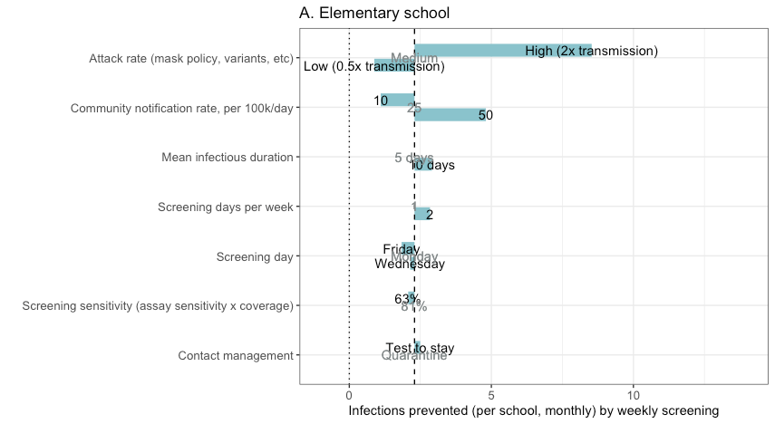

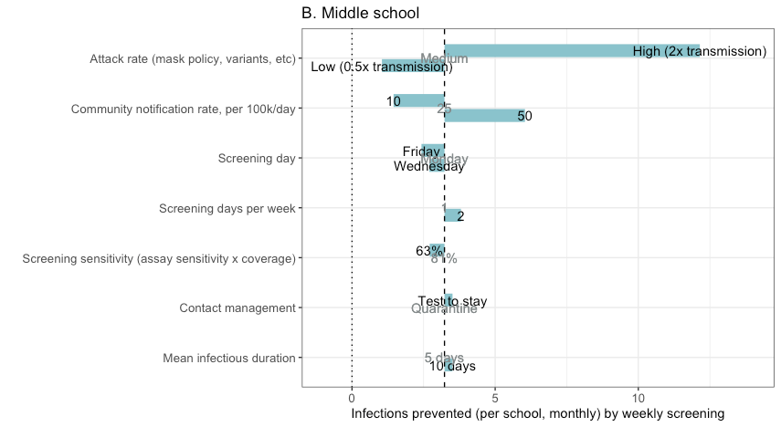

**Table S1. Comparison of transmission, case-detection, operational, and cost outcomes between different schedules and screening frequencies**

|  |  |  |  |  |  |  |  |
| --- | --- | --- | --- | --- | --- | --- | --- |
|  | Infected (proportion of school per month) | Difference in proportion of school infected, per month vs full-time without screening | Proportion of incremental infections prevented (of difference between 5-day no screening and Remote) | Proportion of cases detected | In-person attendance (proportion of school days) | Testing costs ($ per student per month) | Testing + child care costs ($ per student per month) |
| Elementary school, community notification rate 10/100k/day | | | | | | | |
| **5-Day, no screening, quarantine** | 0.01 | 0 | 0 | 0.23 | 0.989 | 0 | 19.03 |
| **5-Day, no screening, test-to-stay** | 0.01 | 0.0002 | -0.06 | 0.23 | 0.999 | 3.47 | 4.36 |
| **5-Day, weekly 10% surveillance, quarantine** | 0.009 | -0.0005 | 0.19 | 0.31 | 0.985 | 18.93 | 44.94 |
| **5-Day, weekly 10% surveillance, test-to-stay** | 0.01 | -0.0002 | 0.06 | 0.35 | 0.999 | 24.25 | 25.56 |
| **5-Day, weekly 20% surveillance, quarantine** | 0.009 | -0.0007 | 0.25 | 0.39 | 0.981 | 27.09 | 58.97 |
| **5-Day, weekly 20% surveillance, test-to-stay** | 0.009 | -0.0005 | 0.17 | 0.44 | 0.999 | 33.98 | 35.59 |
| **5-Day, 1x/week screening, quarantine** | 0.008 | -0.0016 | 0.57 | 0.66 | 0.97 | 69.42 | 120.26 |
| **5-Day, 1x/week screening, test-to-stay** | 0.009 | -0.0013 | 0.46 | 0.73 | 0.999 | 77.81 | 80.25 |
| **5-Day, 2x/week screening, quarantine** | 0.008 | -0.0019 | 0.69 | 0.77 | 0.968 | 124.19 | 178.24 |
| **5-Day, 2x/week weekly screening, test-to-stay** | 0.008 | -0.0017 | 0.61 | 0.88 | 0.998 | 134.03 | 136.86 |
| **Hybrid** | 0.007 | -0.0025 | 0.92 | 0.23 | 0.397 | 0 | 421.76 |
| **Remote** | 0.007 | -0.0028 | 1 | 0 | 0 | 0 | 695.32 |
| Elementary school, community notification rate 50/100k/day | | | | | | | |
| **5-Day, no screening, quarantine** | 0.046 | 0 | 0 | 0.22 | 0.957 | 0 | 71.99 |
| **5-Day, no screening, test-to-stay** | 0.047 | 0.0013 | -0.1 | 0.25 | 0.997 | 14.73 | 19.41 |
| **5-Day, weekly 10% surveillance, quarantine** | 0.042 | -0.0034 | 0.28 | 0.45 | 0.912 | 46.65 | 194.49 |
| **5-Day, weekly 10% surveillance, test-to-stay** | 0.043 | -0.0026 | 0.21 | 0.55 | 0.994 | 80.29 | 89.69 |
| **5-Day, weekly 20% surveillance, quarantine** | 0.041 | -0.0054 | 0.44 | 0.54 | 0.896 | 57.65 | 233.33 |
| **5-Day, weekly 20% surveillance, test-to-stay** | 0.042 | -0.0038 | 0.32 | 0.66 | 0.994 | 107.6 | 118.43 |
| **5-Day, 1x/week screening, quarantine** | 0.039 | -0.0069 | 0.57 | 0.63 | 0.877 | 72.52 | 278.98 |
| **5-Day, 1x/week screening, test-to-stay** | 0.04 | -0.0056 | 0.46 | 0.74 | 0.993 | 107.84 | 119.56 |
| **5-Day, 2x/week screening, quarantine** | 0.038 | -0.0084 | 0.69 | 0.73 | 0.87 | 126.85 | 345.93 |
| **5-Day, 2x/week weekly screening, test-to-stay** | 0.039 | -0.0064 | 0.53 | 0.89 | 0.992 | 169.93 | 183.79 |
| **Hybrid** | 0.036 | -0.0099 | 0.81 | 0.22 | 0.389 | 0 | 435.62 |
| **Remote** | 0.034 | -0.0121 | 1 | 0 | 0 | 0 | 695.32 |
| Middle school, community notification rate 10/100k/day | | | | | | | |
| **5-Day, no screening, quarantine** | 0.012 | 0 | 0 | 0.23 | 0.992 | 0 | 13.48 |
| **5-Day, no screening, test-to-stay** | 0.013 | 0.0006 | -0.12 | 0.26 | 0.999 | 46.62 | 68.93 |
| **5-Day, weekly 10% surveillance, quarantine** | 0.011 | -0.0013 | 0.27 | 0.34 | 0.989 | 4.47 | 5.76 |
| **5-Day, weekly 10% surveillance, test-to-stay** | 0.011 | -0.0008 | 0.16 | 0.42 | 0.999 | 55.46 | 57.6 |
| **5-Day, weekly 20% surveillance, quarantine** | 0.011 | -0.0017 | 0.34 | 0.43 | 0.987 | 23.84 | 42.07 |
| **5-Day, weekly 20% surveillance, test-to-stay** | 0.011 | -0.0015 | 0.3 | 0.52 | 0.999 | 31.24 | 33.09 |
| **5-Day, 1x/week screening, quarantine** | 0.009 | -0.0028 | 0.57 | 0.64 | 0.982 | 70.06 | 100.16 |
| **5-Day, 1x/week screening, test-to-stay** | 0.01 | -0.0027 | 0.54 | 0.74 | 0.998 | 78.57 | 81.31 |
| **5-Day, 2x/week screening, quarantine** | 0.009 | -0.0035 | 0.7 | 0.77 | 0.982 | 125.35 | 155.67 |
| **5-Day, 2x/week weekly screening, test-to-stay** | 0.009 | -0.0031 | 0.62 | 0.9 | 0.998 | 135.35 | 138.51 |
| **Hybrid** | 0.008 | -0.0044 | 0.89 | 0.22 | 0.398 | 0 | 413.93 |
| **Remote** | 0.007 | -0.005 | 1 | 0 | 0 | 0 | 684.79 |
| Middle school, community notification rate 50/100k/day | | | | | | | |
| **5-Day, no screening, quarantine** | 0.055 | 0 | 0 | 0.22 | 0.973 | 0 | 45.46 |
| **5-Day, no screening, test-to-stay** | 0.058 | 0.0023 | -0.11 | 0.28 | 0.996 | 71.78 | 171.71 |
| **5-Day, weekly 10% surveillance, quarantine** | 0.049 | -0.0062 | 0.31 | 0.44 | 0.947 | 18.18 | 24.48 |
| **5-Day, weekly 10% surveillance, test-to-stay** | 0.051 | -0.0049 | 0.24 | 0.59 | 0.993 | 117.73 | 129.93 |
| **5-Day, weekly 20% surveillance, quarantine** | 0.047 | -0.0089 | 0.44 | 0.51 | 0.94 | 52.13 | 139.47 |
| **5-Day, weekly 20% surveillance, test-to-stay** | 0.048 | -0.0073 | 0.36 | 0.66 | 0.993 | 92.72 | 104.17 |
| **5-Day, 1x/week screening, quarantine** | 0.044 | -0.0118 | 0.58 | 0.63 | 0.931 | 74.8 | 189.83 |
| **5-Day, 1x/week screening, test-to-stay** | 0.045 | -0.0103 | 0.5 | 0.76 | 0.992 | 111.96 | 125.28 |
| **5-Day, 2x/week screening, quarantine** | 0.041 | -0.0148 | 0.73 | 0.75 | 0.929 | 131.25 | 248.46 |
| **5-Day, 2x/week weekly screening, test-to-stay** | 0.043 | -0.0123 | 0.6 | 0.9 | 0.991 | 173.31 | 188.37 |
| **Hybrid** | 0.037 | -0.0183 | 0.9 | 0.23 | 0.394 | 0 | 421.16 |
| **Remote** | 0.035 | -0.0204 | 1 | 0 | 0 | 0 | 684.79 |

**References**

[1. Bilinski A, Salomon JA, Giardina J, Ciaranello A, Fitzpatrick MC. Passing the Test: A Model-Based Analysis of Safe School-Reopening Strategies. Ann Intern Med [Internet]. 2021 Jun 8 [cited 2021 Aug 9]; Available from: https://www.acpjournals.org/doi/10.7326/M21-0600](https://www.zotero.org/google-docs/?cSlXNr)

[2. Gatto M, Bertuzzo E, Mari L, Miccoli S, Carraro L, Casagrandi R, et al. Spread and dynamics of the COVID-19 epidemic in Italy: Effects of emergency containment measures. Proc Natl Acad Sci USA. 2020 May 12;117(19):10484–91.](https://www.zotero.org/google-docs/?cSlXNr)

[3. He X, Lau EHY, Wu P, Deng X, Wang J, Hao X, et al. Temporal dynamics in viral shedding and transmissibility of COVID-19. Nat Med. 2020 Apr 15;1–4.](https://www.zotero.org/google-docs/?cSlXNr)

[4. Kerr CC, Stuart RM, Mistry D, Abeysuriya RG, Hart G, Rosenfeld K, et al. Covasim: an agent-based model of COVID-19 dynamics and interventions. medRxiv. 2020 May 15;2020.05.10.20097469.](https://www.zotero.org/google-docs/?cSlXNr)

[5. He D, Zhao S, Lin Q, Zhuang Z, Cao P, Wang MH, et al. The relative transmissibility of asymptomatic COVID-19 infections among close contacts. International Journal of Infectious Diseases. 2020 May 1;94:145–7.](https://www.zotero.org/google-docs/?cSlXNr)

[6. Li Q, Guan X, Wu P, Wang X, Zhou L, Tong Y, et al. Early Transmission Dynamics in Wuhan, China, of Novel Coronavirus–Infected Pneumonia. New England Journal of Medicine. 2020 Jan 29;0(0):null.](https://www.zotero.org/google-docs/?cSlXNr)

[7. Firth JA, Hellewell J, Klepac P, Kissler SM, CMMID COVID-19 working group, Kucharski AJ, et al. Combining fine-scale social contact data with epidemic modelling reveals interactions between contact tracing, quarantine, testing and physical distancing for controlling COVID-19 [Internet]. Epidemiology; 2020 May [cited 2020 Jun 2]. Available from: http://medrxiv.org/lookup/doi/10.1101/2020.05.26.20113720](https://www.zotero.org/google-docs/?cSlXNr)

[8. Endo A, Centre for the Mathematical Modelling of Infectious Diseases COVID-19 Working Group, Abbott S, Kucharski AJ, Funk S. Estimating the overdispersion in COVID-19 transmission using outbreak sizes outside China. Wellcome Open Res. 2020 Apr 9;5:67.](https://www.zotero.org/google-docs/?cSlXNr)

[9. Byambasuren O, Cardona M, Bell K, Clark J, McLaws M-L, Glasziou P. Estimating the extent of asymptomatic COVID-19 and its potential for community transmission: Systematic review and meta-analysis. Official Journal of the Association of Medical Microbiology and Infectious Disease Canada. 2020 Dec 1;5(4):223–34.](https://www.zotero.org/google-docs/?cSlXNr)

[10. Fontanet A, Grant R, Tondeur L, Madec Y, Grzelak L, Cailleau I, et al. SARS-CoV-2 infection in primary schools in northern France: A retrospective cohort study in an area of high transmission. medRxiv. 2020 Jun 29;2020.06.25.20140178.](https://www.zotero.org/google-docs/?cSlXNr)

[11. Stein-Zamir C, Abramson N, Shoob H, Libal E, Bitan M, Cardash T, et al. A large COVID-19 outbreak in a high school 10 days after schools’ reopening, Israel, May 2020. Eurosurveillance. 2020 Jul 23;25(29):2001352.](https://www.zotero.org/google-docs/?cSlXNr)

[12. Dattner I, Goldberg Y, Katriel G, Yaari R, Gal N, Miron Y, et al. The role of children in the spread of COVID-19: Using household data from Bnei Brak, Israel, to estimate the relative susceptibility and infectivity of children [Internet]. Infectious Diseases (except HIV/AIDS); 2020 Jun [cited 2020 Jun 19]. Available from: http://medrxiv.org/lookup/doi/10.1101/2020.06.03.20121145](https://www.zotero.org/google-docs/?cSlXNr)

[13. Park YJ, Choe YJ, Park O, Park SY, Kim Y-M, Kim J, et al. Early Release - Contact Tracing during Coronavirus Disease Outbreak, South Korea, 2020 - Volume 26, Number 10—October 2020 - Emerging Infectious Diseases journal - CDC. [cited 2020 Aug 1]; Available from: https://wwwnc.cdc.gov/eid/article/26/10/20-1315_article](https://www.zotero.org/google-docs/?cSlXNr)

[14. Fontanet A, Tondeur L, Madec Y, Grant R, Besombes C, Jolly N, et al. Cluster of COVID-19 in northern France: A retrospective closed cohort study. medRxiv. 2020 Apr 23;2020.04.18.20071134.](https://www.zotero.org/google-docs/?cSlXNr)

[15. Mutesa L, Ndishimye P, Butera Y, Souopgui J, Uwineza A, Rutayisire R, et al. A pooled testing strategy for identifying SARS-CoV-2 at low prevalence. Nature. 2021 Jan;589(7841):276–80.](https://www.zotero.org/google-docs/?cSlXNr)

[16. Lohse S, Pfuhl T, Berkó-Göttel B, Rissland J, Geißler T, Gärtner B, et al. Pooling of samples for testing for SARS-CoV-2 in asymptomatic people. The Lancet Infectious Diseases. 2020 Nov 1;20(11):1231–2.](https://www.zotero.org/google-docs/?cSlXNr)

[17. Goldstein E, Lipsitch M, Cevik M. On the Effect of Age on the Transmission of SARS-CoV-2 in Households, Schools, and the Community. The Journal of Infectious Diseases [Internet]. 2020 Oct 29 [cited 2021 Jan 24];(jiaa691). Available from: https://doi.org/10.1093/infdis/jiaa691](https://www.zotero.org/google-docs/?cSlXNr)

[18. Madewell ZJ, Yang Y, Longini IM, Halloran ME, Dean NE. Household Transmission of SARS-CoV-2: A Systematic Review and Meta-analysis. JAMA Netw Open. 2020 Dec 14;3(12):e2031756.](https://www.zotero.org/google-docs/?cSlXNr)

[19. Fung HF, Martinez L, Alarid-Escudero F, Salomon JA, Studdert DM, Andrews JR, et al. The Household Secondary Attack Rate of Severe Acute Respiratory Syndrome Coronavirus 2 (SARS-CoV-2): A Rapid Review. Clinical Infectious Diseases. 2020 Oct 12;ciaa1558.](https://www.zotero.org/google-docs/?cSlXNr)

[20. Alonso S, Alvarez-Lacalle E, Català M, López D, Jordan I, García-García JJ, et al. Age-dependency of the Propagation Rate of Coronavirus Disease 2019 Inside School Bubble Groups in Catalonia, Spain. The Pediatric Infectious Disease Journal [Internet]. 2021 Jul 29 [cited 2021 Aug 9]; Available from: https://journals.lww.com/pidj/Abstract/9000/Age_dependency_of_the_Propagation_Rate_of.95714.aspx](https://www.zotero.org/google-docs/?cSlXNr)

[21. Doyle T. COVID-19 in Primary and Secondary School Settings During the First Semester of School Reopening — Florida, August–December 2020. MMWR Morb Mortal Wkly Rep [Internet]. 2021 [cited 2021 May 14];70. Available from: https://www.cdc.gov/mmwr/volumes/70/wr/mm7012e2.htm](https://www.zotero.org/google-docs/?cSlXNr)

[22. Gettings J. Mask Use and Ventilation Improvements to Reduce COVID-19 Incidence in Elementary Schools — Georgia, November 16–December 11, 2020. MMWR Morb Mortal Wkly Rep [Internet]. 2021 [cited 2021 Aug 9];70. Available from: https://www.cdc.gov/mmwr/volumes/70/wr/mm7021e1.htm](https://www.zotero.org/google-docs/?cSlXNr)

[23. Falk A. COVID-19 Cases and Transmission in 17 K–12 Schools — Wood County, Wisconsin, August 31–November 29, 2020. MMWR Morb Mortal Wkly Rep [Internet]. 2021 [cited 2021 Apr 21];70. Available from: https://www.cdc.gov/mmwr/volumes/70/wr/mm7004e3.htm](https://www.zotero.org/google-docs/?cSlXNr)

[24. Lessler J, Grabowski MK, Grantz KH, Badillo-Goicoechea E, Metcalf CJE, Lupton-Smith C, et al. Household COVID-19 risk and in-person schooling. Science [Internet]. 2021 Apr 29 [cited 2021 May 21]; Available from: https://science.sciencemag.org/content/early/2021/04/28/science.abh2939](https://www.zotero.org/google-docs/?cSlXNr)

[25. The Association of Opening K-12 Schools with the Spread of COVID-19 in the United States: County-Level Panel Data Analysis [Internet]. [cited 2021 Aug 9]. Available from: https://www.medrxiv.org/content/10.1101/2021.02.20.21252131v2](https://www.zotero.org/google-docs/?cSlXNr)

[26. Goldhaber D, Imberman S, Strunk KO, Hopkins B, Brown N, Harbatkin E, et al. To What Extent Does In-Person Schooling Contribute to the Spread of COVID-19? Evidence from Michigan and Washington [Internet]. 2020 Dec [cited 2021 Jan 24]. Available from: https://epicedpolicy.org/does-in-person-schooling-contribute-to-the-spread-of-covid-19/](https://www.zotero.org/google-docs/?cSlXNr)

[27. CDC. Delta Variant: What We Know About the Science [Internet]. Centers for Disease Control and Prevention. 2021 [cited 2021 Aug 9]. Available from: https://www.cdc.gov/coronavirus/2019-ncov/variants/delta-variant.html](https://www.zotero.org/google-docs/?cSlXNr)

[28. Campbell F, Archer B, Laurenson-Schafer H, Jinnai Y, Konings F, Batra N, et al. Increased transmissibility and global spread of SARS-CoV-2 variants of concern as at June 2021. Eurosurveillance. 2021 Jun 17;26(24):2100509.](https://www.zotero.org/google-docs/?cSlXNr)

[29. Sheikh A, McMenamin J, Taylor B, Robertson C, Public Health Scotland and the EAVE II Collaborators. SARS-CoV-2 Delta VOC in Scotland: demographics, risk of hospital admission, and vaccine effectiveness. Lancet. 2021 Jun 26;397(10293):2461–2.](https://www.zotero.org/google-docs/?cSlXNr)

[30. Lopez Bernal J, Andrews N, Gower C, Gallagher E, Simmons R, Thelwall S, et al. Effectiveness of Covid-19 Vaccines against the B.1.617.2 (Delta) Variant. New England Journal of Medicine. 2021 Jul 21.](https://www.zotero.org/google-docs/?cSlXNr)

1. The common approach of comparing percent positivity from in-school testing to population testing is inappropriate, as community testing encompasses primarily exposed symptomatic individuals with a much higher probability of infection than randomly selected individuals.